Corporate Training Through Me

Tyonia Wright

University of North Texas

Distributed PhD in Learning Technologies

LTEC 6250

**Introduction**

“In a modern economy, the investment in human capital by firms is crucial to foster technological adoption and foster productivity growth” (Almeida & Aterido, 2015). In an effort to increase productivity, many institutions and organizations have developed training programs for their associates. Organizations that previously did not have any training have realized the benefits of implementing training for some, if not all, associates. In fact, Seraphim (2010) notes that,

Faced with the globalization of markets and an increasing domestic and international competition, most firms are coming to the conclusion that their survival depends on their capacity to maintain well trained employees that continually acquire new knowledge and skills, enabling thus the firm to respond rapidly to market opportunities and threats (p. 109).

The trainings can often be separated into two types, formal and informal. Formal trainings are those that include teachers and resources that are dedicated solely to training while informal trainings are those that allow for mainly on the job training with the learner taking notes. In organizations that utilize informal training, training serves as a secondary role for instructors.

In a previous role at Edward Jones, I served in an organization that focused on informal training for most roles. Individuals in my role and other support areas were provided mainly on the job training. While most leaders mentioned the objective of eventually moving to more formalized training, this was not accomplished during my time with the company. As a part of my role, I was asked to train newer associates on various job duties. I was also asked to develop corporate training materials for future new hires while handling my regularly assigned tasks. This paper will focus on me as a corporate trainer and microsystem or subsystem of the corporate training environment at Edward Jones. Several areas will be explored including the boundaries that existed within my system, system inputs, and system outputs.

**Microsystems**

Systems thinking provides for looking at a system in terms of its whole impact instead of the combined impact of the individual parts. This approach is thought to help with decision making in complex systems (Yurtseven & Buchanan, 2016). In recent times systems thinking has become a focus for individuals in many fields. Cabrera, Colosi, and Lobdell (2008) state that those interested in systems thinking include “practitioners in evaluation, public health, education, and business who attempt to implement systems thinking in their organizations, and scholars and researchers who study systems thinking” (Popularity and promise of systems thinking, para. 1).

While systems thinking focuses on looking at the overall system, in some instances it is helpful to look at the system on a more detailed level. This level is referred to as the micro or sub level (Banathy, 1992). Looking at the system from the student level allows us to examine the system in a way that shows additional details that are not quickly seen at the more general level. Looking at the system from the student level in a system such as the University of North Texas allows us to examine the system in a way that shows additional details not quickly seen at the more general level. For this paper, I am the microsystem to explored within the corporate training environment.

**Boundaries**

To provide a more complete understand the complex microsystem that is me, it is essential to explore the boundaries, various inputs, outputs, and connections that exist within and impact the system. We will begin my looking at the boundaries of my microsystem.

As a trainer at Edward Jones, I was limited by several different types of boundaries. These boundaries were based on inputs from expectations, policies, requirements, constraints, and rules as Banathy (1992) mentions. These inputs included economic and political based ideas. One expectation from leadership was that all new employees should be trained by more tenured department associates instead of a dedicated team of trainers. Because the company has a finite amount of money that it can earn, it likewise has a finite amount of money it can spend each year. During my time with Edward Jones, the department leaders determined their own corporate budgets. The budgets included the costs that each department would spend on salaries, training, and other items. If leaders in an area decided not to include additional funds for training in the budget, the area would be forced to find other means for training its associates.

Another input that effected my microsystem involved the need for leader approval. Associates had to be given leader approval to do anything that involved spending company funds. For example, if a trainer decided that the best way for associates to learn a new skill was through a system that was not currently in use, a leader would need to approve new software installation for the team before the trainer could move forward with designing the new training. If the leader did not have a good relationship with the associate, they could block any resources that would require company funds. This in turn created a boundary for myself and other trainers.

A third input that greatly impacted the boundaries of my microsystem were the regulatory requirements for the financial services industry. Because of past economic challenges, the financial services industry had to meet new requirements for associate training. While I focused mainly on job specific training, I had to remain aware of new regulations so that I could ensure that newer associates were being taught how to complete their jobs while being compliant to regulatory requirements. Figure 1 shows a system-environment model of my microsystem based on Banathy’s (1992) Revised Systems-Environment model.

*Figure 1*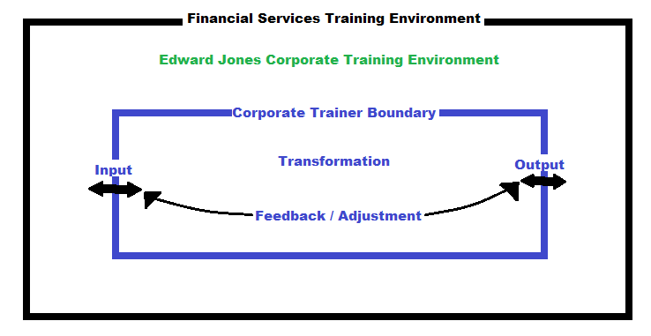

**Feedback**

According to Banathy (1992), “Self-regulating adaptiveness is triggered by: (1) sensing system-relevant changes in the environment, (2) receiving information from the environment on changed requirements, and (3) the process of FEEDBACK, by which information is introduced into the system about the inadequacy of the output” (p. 32). In my case, all three of these triggers occurred. When I taught someone a task, I would watch them to get a sense of how well they were grasping the concepts. If they did not seem to understand, I could sense it and make necessary adjustments. Additionally, I was aware of changes in learning requirements when the process for specific tasks were changed. When this occurred, I adjusted the training to fit the new requirements. Lastly, adjusting to feedback was a large part of my role as a corporate trainer. To ensure that my learners received the best training, I had to listen to feedback from learners and leaders. The feedback that I received was considered when developing and making changes to training and associated materials.

**Other Inputs**

Banathy (1992) notes that Educational Activity Systems have a past, operate in the present, and move toward the future. To understand more about my microsystem, it is important to explore more of the various inputs and past that affect my training style. Illustration 2 provides a mindmap of the inputs from my past and present that affect my microsystem and their connections. The remainder of this paper will explore illustration 2 and provide additional details on the inputs, outputs and connections that exist and how they impact areas of my training microsystem.

*Figure 2*

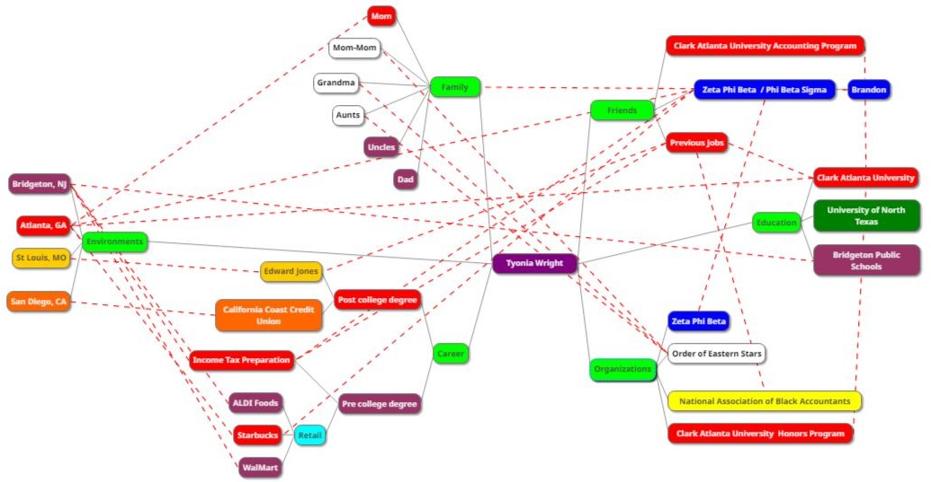

**Family and Friends**

One of the major inputs that affects my microsystem is my family and friends. The values that I have learned from my family impact every area of my life. I was taught by my mother to treat others how I would like to be treated. When I trained a new associate, I always attempted to be positive and give feedback in a way that was respectful because that it how I would like to be treated. Another value that I utilize in my training environment that I developed from my family is listening to others. When I trained others, I made sure to listen to what my learners told me. This allowed me to provide training that the learner could understand.

I developed my skills in motivation and understanding with the help of my friends. My friends taught me that not everyone has the same experiences that I have had. For example, I am from a small town while many of my friends were raised in major cities. Being exposed to the experiences of others helped me to broaden my ability to understand others. I also learned more about how to motivate individuals who have a choice on whether to listen and take my advice. I have always been around individuals who felt comfortable asking me for advice but being around the friends that I met in college helped me to learn more about motivation. I learned to motivate others who are not required to listen to me by assisting my friends.

**College**

Another significant impact on the development of my microsystem is the colleges that I have attended. I earned my Bachelor’s and Master’s degrees from Clark Atlanta University in Atlanta, GA. During my time in Atlanta, I was exposed to many things that still impact my daily decisions. I was taught to complete tasks that help me to focus on my passion instead of focusing solely on monetary motivation. This approach allowed me to teach with a passion that was not based on money. When I taught learners, I was motivated by helping them to learn. This ensured that I did not discouraged if external motivators were no longer sufficient.

After taking a few years off from attending college, I entered the Distributed PhD program for Learning Technologies at the University of North Texas. After entering this program, I found myself adjusting the way that I delivered my trainings. Because the program is almost entirely online, I was exposed to online resources that I had never been exposed to previously. While creating training materials, I used some of my newfound resources.

**Organizations**

Involvement in various organizations has helped to shape my training microsystem. This was done largely by allowing me to interact with individuals I would not have met otherwise. During my time at Clark Atlanta University, I joined the Honors Program. While in this organization, I networked with other students. One of those students helped to recruit me to Edward Jones where I assisted in training. Additionally, while in this organization, I was taught to appropriately manage my time and prioritize tasks. Having these skills helped me to successfully complete my regular tasks in addition to training others.

**Career Experience**

Prior to working at Edward Jones, I had opportunities to work in several other companies. Some of my previous employers had very detailed training programs while others did not. These experiences provided me with insights into what I would want in training as a new associate. I also had an opportunity to revise training materials and train newer associates at a few companies before moving to St Louis to work for Edward Jones. While working for Aldi Foods, I learned how to revise training materials in an efficient way with the help of others. This gave me the guidance that I needed when designing training for Edward Jones. As an Income Tax Preparer, I was asked to train new associates. This helped to give me some background on how to train others.

**Conclusion**

The training environments within the United States are essential in training individuals to accomplish many necessary tasks. Each year organizations spend billions on training to ensure reduced errors and competitiveness (Salas, E., Tannenbaum, S., Kraiger, K. & Smith-Jentsch, K., 2012). Within the US the financial services training environment is constantly changing. As a trainer in this system, I had to operate within my boundaries while remaining adaptable. As a microsystem, I operated based on the many inputs that existed within my system and connecting systems. These inputs helped to shape my practices and ultimately my outputs. Feedback was then used to adjust my outputs to meet the expectations of those in the larger Edward Jones training system. All in all, my microsystem was greatly influenced by the larger system and the various inputs. This paper explored the many ways that this occurred.

**References**

Almeida, R. K., & Aterido, R. (2015). Investing in formal on-the-job training: Are SMEs lagging much behind?*IZA Journal of Labor & Development, 4*(1), 1-23. doi:http://dx.doi.org/10.1186/s40175-015-0029-3

Banathy, B. H. (1992). A systems view of education: Concepts and principles for effective practice. Englewood Cliffs, NJ: Educational Technology Publications, Inc.

Cabrera, D., Colosi, L., Lobdell, C. (2008). Systems thinking. *Evaluation and program planning*, *31*(3), 299-310.

Salas, E., Tannenbaum, S., Kraiger, K. & Smith-Jentsch, K. (2012). The science of training and development in organizations: What matters in practice. *Psychol Sci Public Interest. 12*(2), 74-101.

Seraphim, K. K. (2010). Enticers and barriers to e-learning based distance corporate training: The case of a greek bank. Turkish Online Journal Of Distance Education (TOJDE), 11(4), 109-120.

Yurtseven, M. K., & Buchanan, W. (2016). Decision making and systems thinking: Educational issues.*American Journal of Engineering Education, 7*(1), 19-28. doi:http://dx.doi.org/10.19030/ajee.v7i1.9682